**VISHNU AYURVEDA COLLEGE**

**AGARTHA STUDENTS UNION**

**2023-2024**

**The Agartha Students Union (2023-2024)** Organised the following Programs:

1) Union Inauguration and Oath Taking Ceremony was inaugurated by Dr Usman Sahib, Principal of Vishnu Ayurveda College on 23/08/2023. 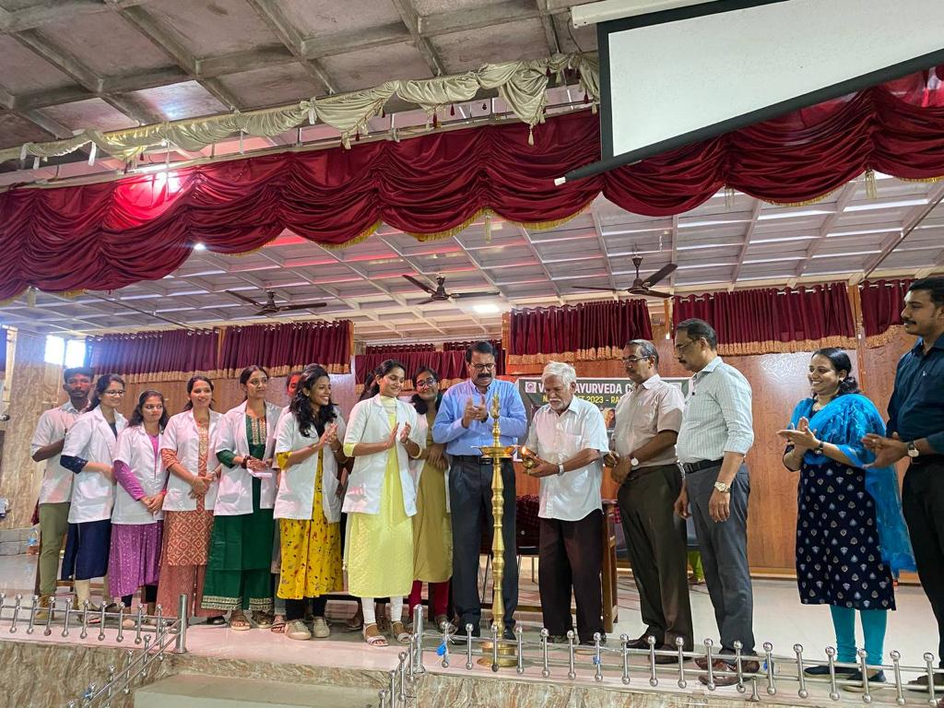

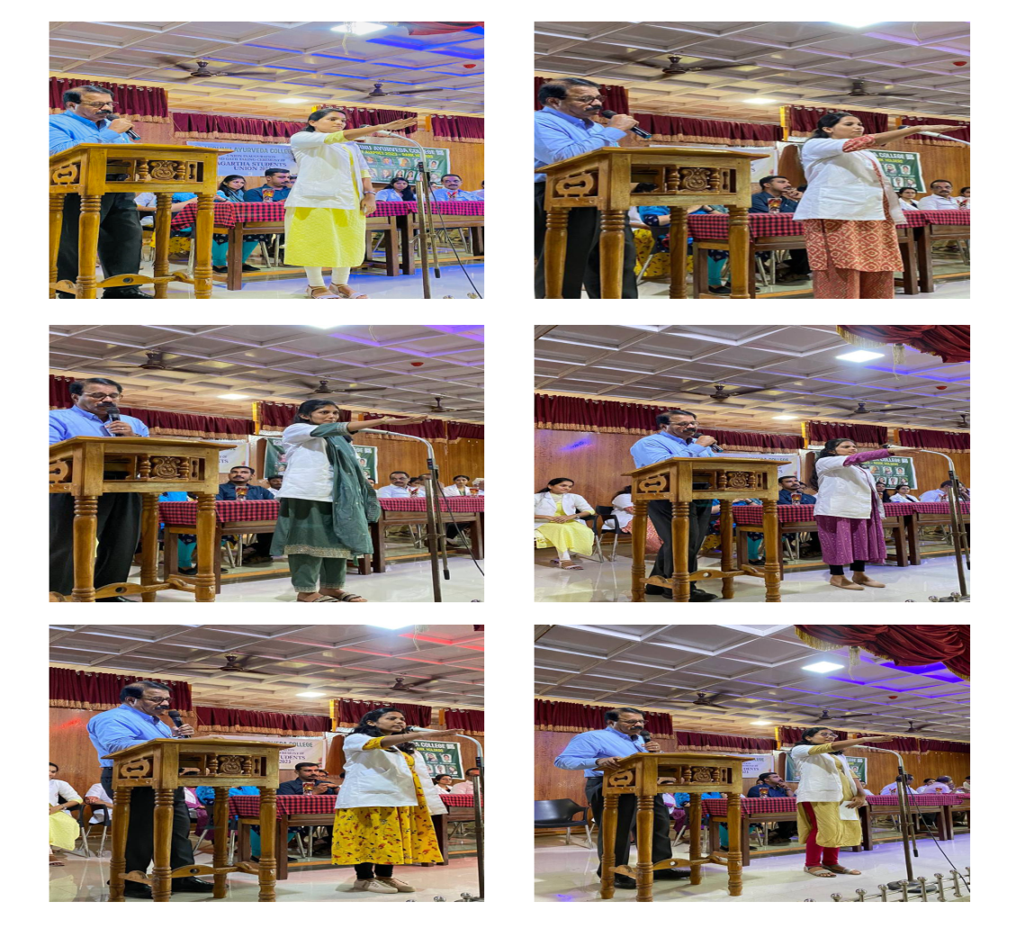

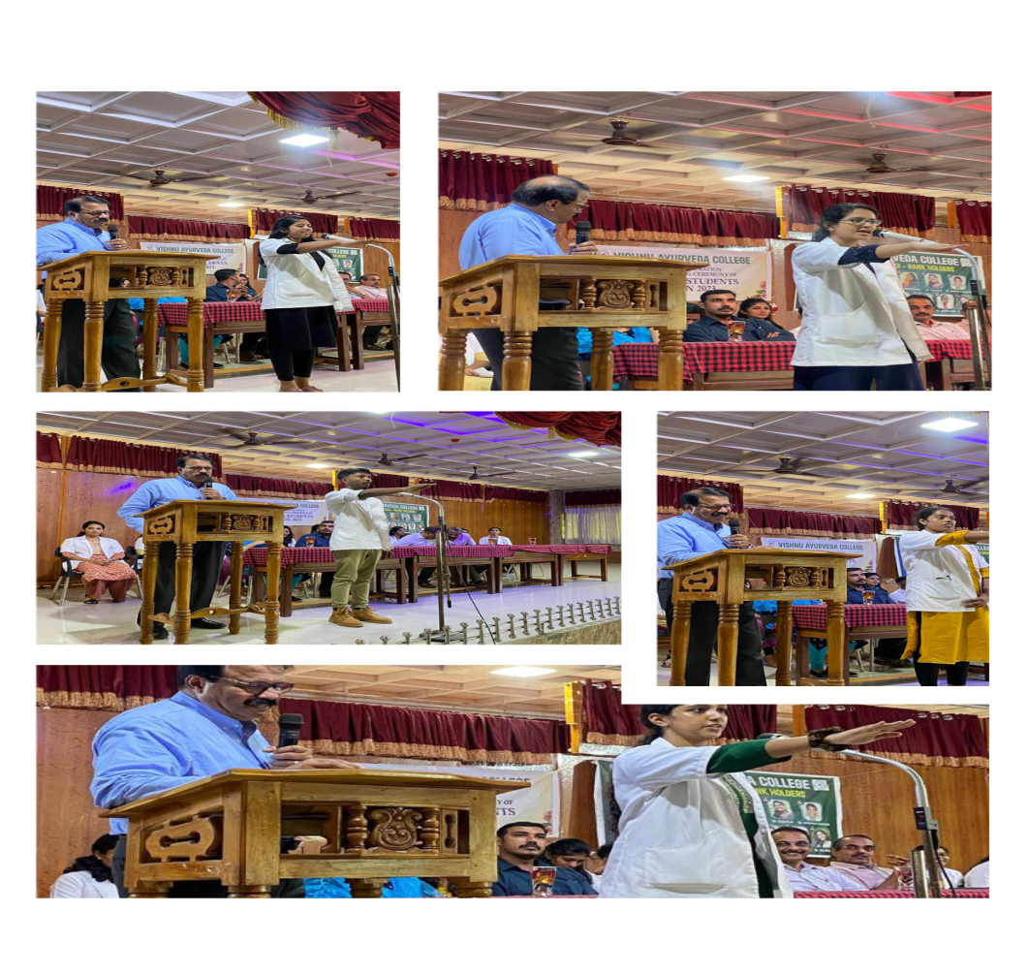

2) International Yoga Day was inaugurated by Dr Ramachandran Nair Sir, Director of Vishnu Ayurveda College on 21-06-2023.

Various activities like Yoga Dance, Yoga Geetham, Suryanamskara demonstration and Talk on Yoga for Menstrual Health by Dr Yamuna, Associate Professor and HOD of Department of Prasutitantra and Streeroga were held on that Day.

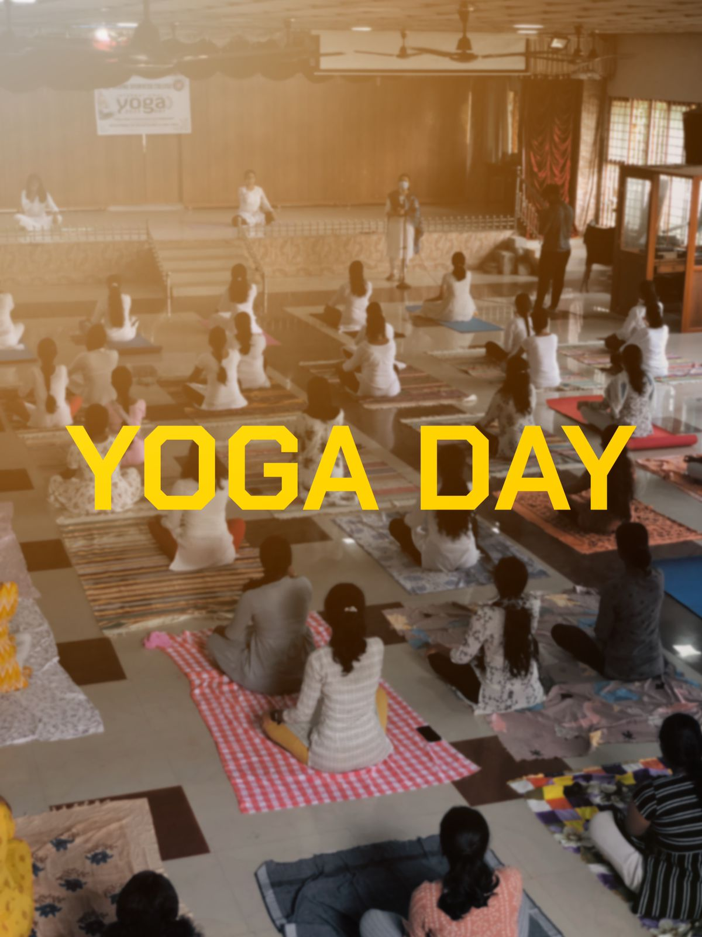

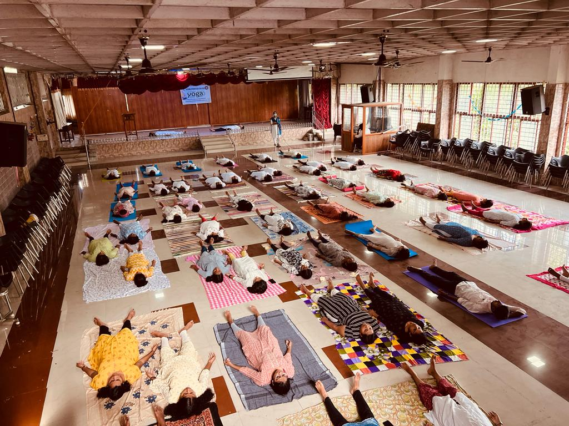

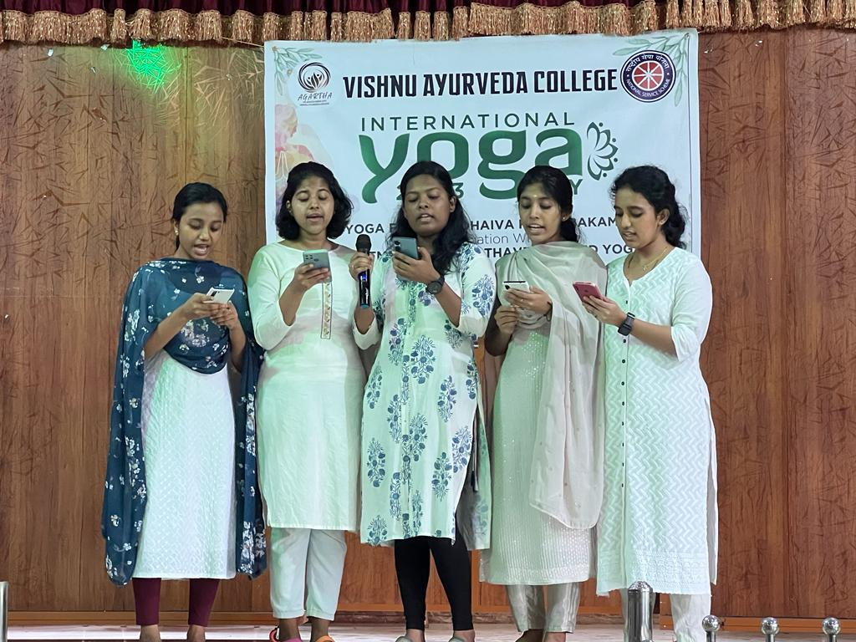

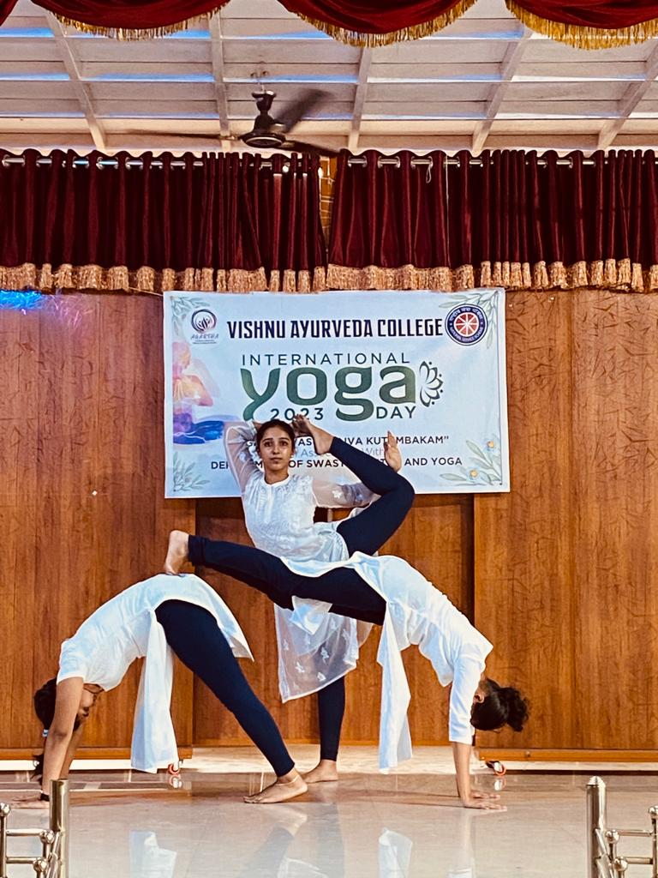

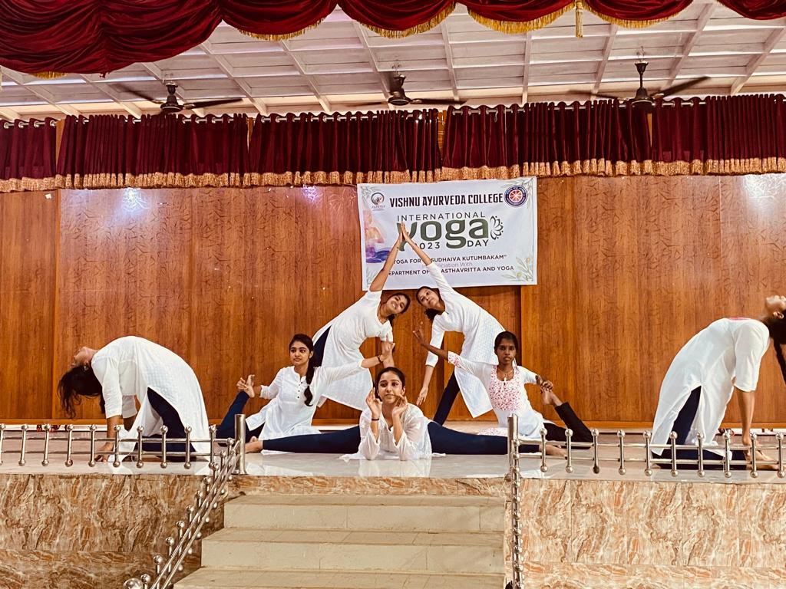

3) A Function to Honour the NEET AIAPGET2023 Rank Holders was held on 24-08-2023and was inauguarated by Dr Ramachandran Nair, Director of Vishnu Ayurveda College.

Mementos were distributed to the Rank Holders by Principal Dr Usman Sahib.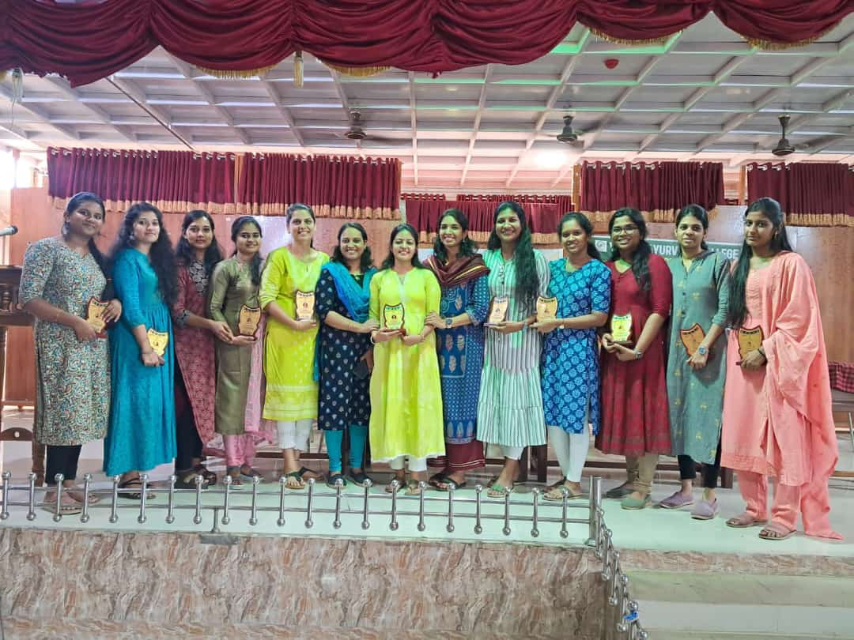

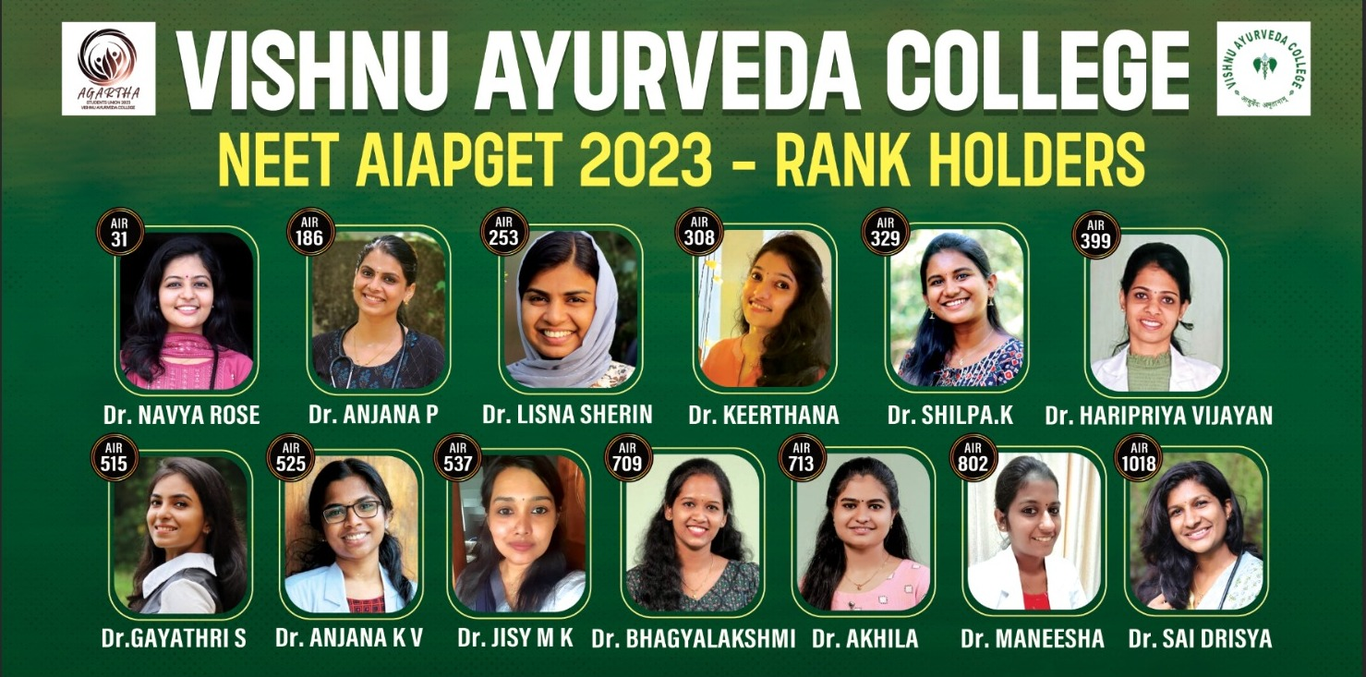

4) “8th Ayurveda Day” was celebrated on 10-11-2023. Chief Guest of the Day was Dr. Sethumadhavan, Chief Physician and Founder of Padinharkkara Ayurveda Hospital and Research Centre Ottapalam.

As part of this a Rally in association with Department of Panchakarma and led by the Principal Dr Usman Sahib.

